Contents

Review Eat User Guide 1

Getting to know the software 1

Login Screen 2

Registration Screen 3

Update Password Screen 4

Delete Account 5

Review Eat Screen 6

Add Review Screen 7

View Review Screen 8

How to register a user? 9

How to login? 10

How to update password? 11

How to add a review? 12

How To view Reviews? 13

How to delete your account? 14

Features of Review Eat (Tips and Tricks) 15

Search Box 15

Filter restaurant based on cuisine 15

Sort the results 15

Want to go back to previous window? 15

Logging out? 15

Trouble Shooting 16

Logging In 16

Registering to the system 17

Updating the password 18

Deleting an account 18

Adding a review 19

Developers Contact Information 20

Copyrights 20

# Review Eat User Guide

Review Eat is a software that is designed for an enthusiastic diner who would want to share their dining experience. Current Version of Review Eat can register a user with valid information provided, displaying restaurants that have been added by the admin, allowing users to add reviews onto the restaurant and rank restaurants based on the ratings.

This documentation is a step to step guide on how to use the software. The documentation is broken down into various steps that are listed below:

Getting to Know the software

How to register a user?

How to login?

How to update the password?

How to add a review?

How to delete an account?

Features of Review Eat (Tips and Tricks)

Trouble Shooting

Contact Details

## Getting to know the software

Review Eat features various pages or windows, and this part of documentation provides an overview of those windows.

### Login Screen

Here is the first screen that you will see when you open the software.



1. Username Text Field
2. Password Text Field
3. Login Button
4. Update Password Button
5. Delete Account Button
6. Register Button

### Registration Screen

This screen presents you with a form where you can enter your details, and you can register to the system.

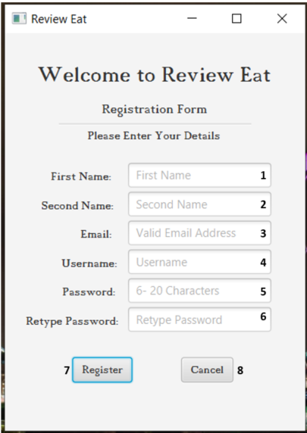

1. Text Field for Users First Name
2. Text Field for Users Second Name
3. Email Text Field
4. Username Text Field
5. Password Text Field
6. Text Field for retyping the password
7. Register Button
8. Cancel Button

### Update Password Screen

This screen allows you to update your password after validating your account.

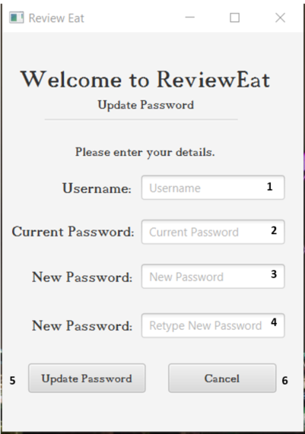

1. Username Text Field
2. Text Field to enter current password
3. Text Field to type a new password
4. Text Field to retype new password
5. Update Password Button
6. Cancel Button

### Delete Account

This screen allows you to delete your account from the system after validating your details.

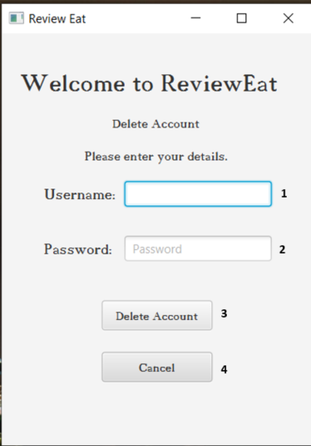

1. Username Text Field
2. Password Text Field
3. Delete Account Button
4. Cancel Button

### Review Eat Screen

After you log in, this is the screen that you will see. Its the main screen of the software. Here, you can see all the restaurants that have been added to the system, view their rating, search for them, and add a review by selecting them.

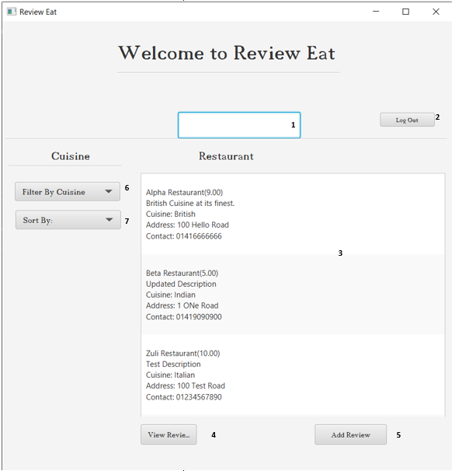

1. Search Box
2. Log Out Button
3. List View of restaurants. Each restaurant is selectable.
4. View Reviews Button
5. Add Review Button
6. Filter Choice Box to filter by cuisine.
7. Sort Choice Box.

### Add Review Screen

When you click add a review on Review Eat Screen, you will see this screen. This screen allows you to add reviews on selected restaurants.

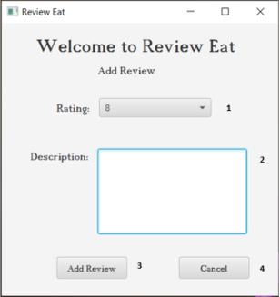

1. Rating Drop Box
2. Description Text Area
3. Add Review Button
4. Cancel Button

### View Review Screen

When on Review Eat Screen, you can select a restaurant and you can click on View Reviews button to view all the reviews that have been added to that restaurant.

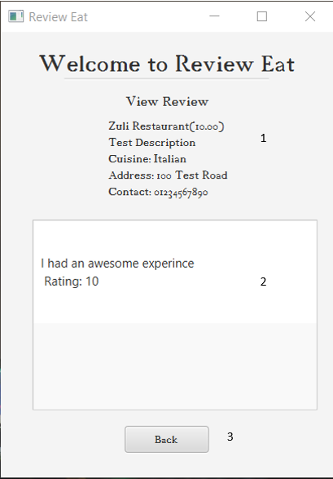

1. Restaurant Details
2. List view of all the reviews
3. Back Button

## How to register a user?

Here are the steps that you need to follow to register a user:

1. When you open the software, you are presented with a login screen.
2. On the bottom left side of the screen, there is a button labelled “Register Here”. Click that button.
3. Now, you should see a registration screen with the registration form.
4. All the text boxes are **mandatory;** you should fill all the boxes.
5. You are required to enter your first name, second name, email, the username (you can choose your username), password and retype the password.
6. Once you enter all the details, click the “Register” button and it should show a confirmation alert that you have successfully registered to the system. Just click on the “OK” button.
7. It will take you to the login screen.

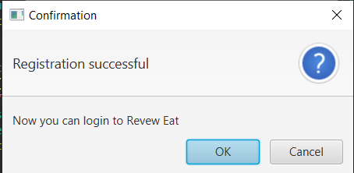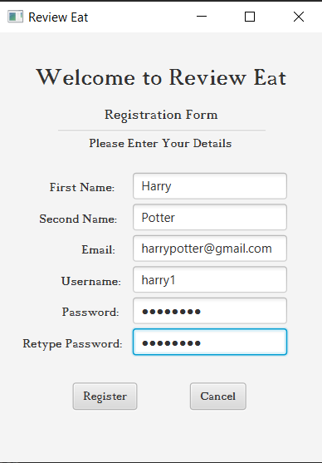

## How to login?

Here are the steps that you need to follow during logging in:

1. When you open the software, you can see a login screen. There are two text fields labelled username and password.
2. Enter your username on the username text field.
3. Enter your password on the password text field.
4. Click the “Login” button.
5. If your details are correct, it should log you into the system, and you can see the Review Eat screen.

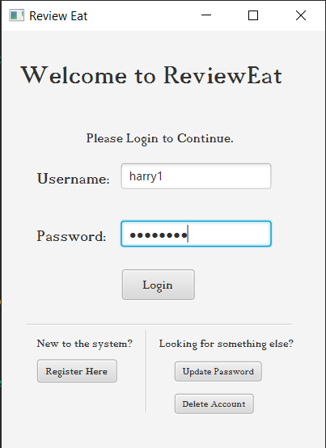

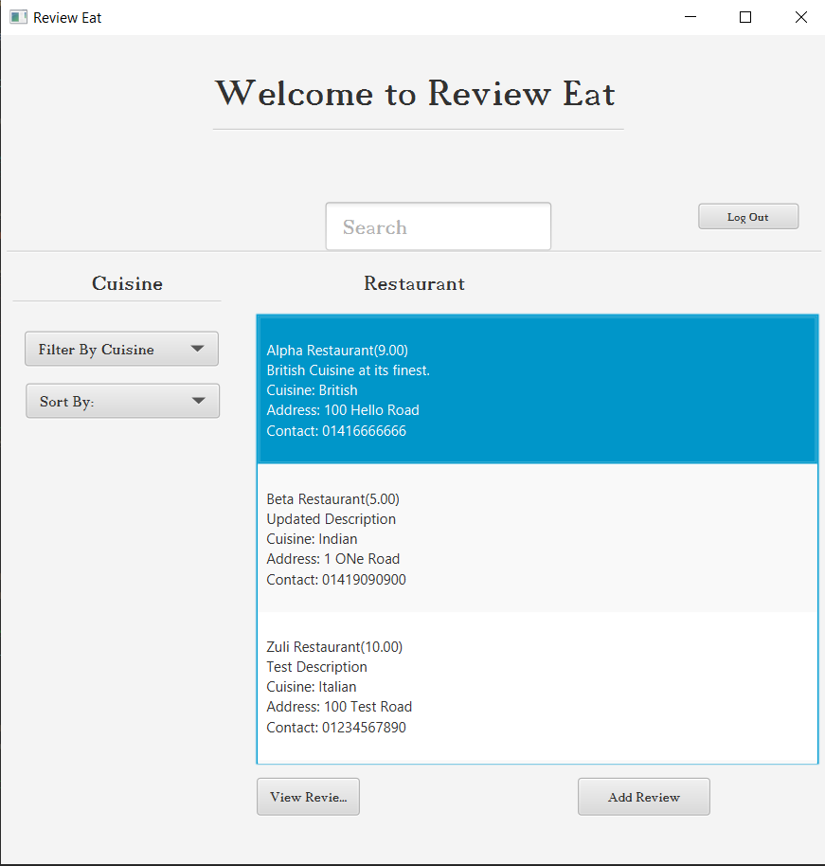

## How to update password?

Here are the steps that you need to follow to change your password:

1. When on the login screen, click the “Update Password” button on bottom right side of the window.
2. When clicked, the system takes you to the Update Password window.
3. Now, type in your username, your current password, your new password and retype the new password.
4. All the fields are **mandatory**, so make sure you enter the details correct.
5. 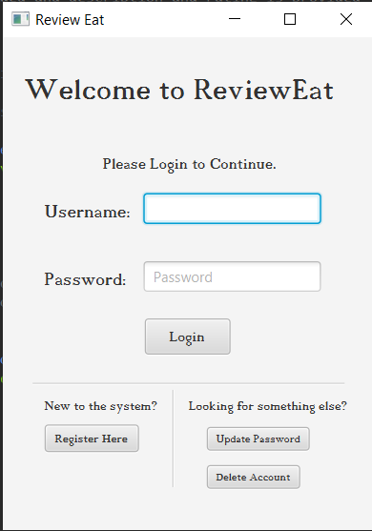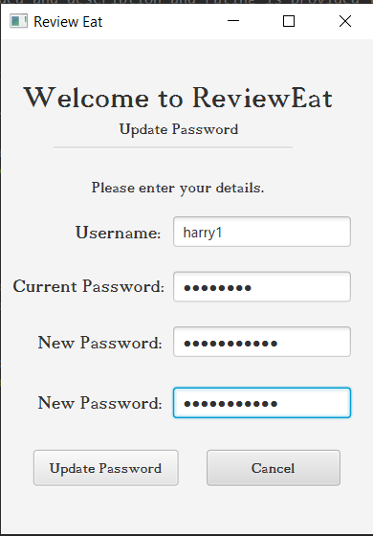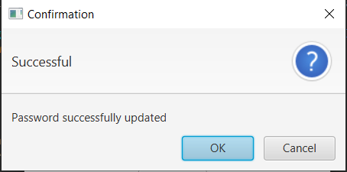When you have entered all the details, click on the “Update Password” button. Now, it should show you a confirmation window with a message that your password has been updated.

## How to add a review?

Here are the steps that you need to follow to add a review:

1. When you log in, you are presented with the Review Eat screen. There, you can see a list of restaurants that have been added by the admin. Click on the restaurant that you want to review.
2. When you click on a restaurant, it should be selected (highlighted in blue). Now click on “Add Review” button at the bottom right of the screen.
3. You should be taken to add review screen. Select the rating from the drop-down choice. Write a detailed review on the text area provided.
4. Click on “Add Review” button at the bottom left.
5. You should see a confirmation alert. Click the “OK” button. 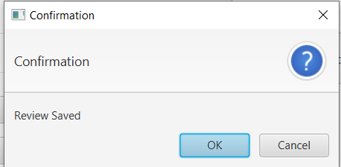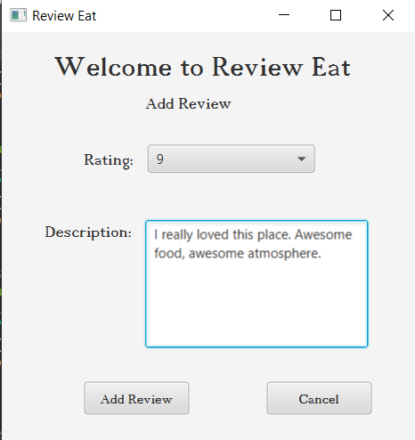



## How To view Reviews?

Here are the steps to follow to view the reviews:

1. When on Review Eat Screen, select a restaurant. (When selected the restaurant should be highlighted in blue.
2. When done so, click on “View Reveiws” button on the bottom left of the screen.
3. You will be taken to the View Review screen where you can see all the reviews for that restaurant.

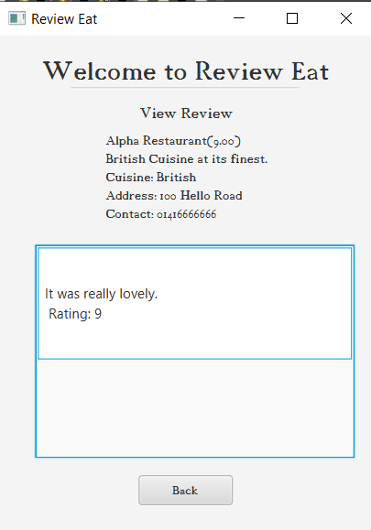

## How to delete your account?

You do not want your account to be saved in the database anymore? No worries. Here are the steps you can follow to delete your account:

1. When on the Login window, click the “Delete Account” button on the bottom right corner of the window.
2. You should see the Delete Account screen. When at delete account screen, type in your username and password.
3. All the fields are **mandatory**. Now, click on “Delete Account” button.
4. You should see a confirmation dialogue box. To confirm your request, click “OK”.
5. 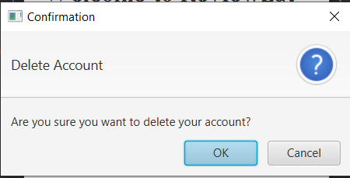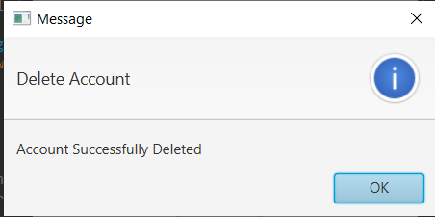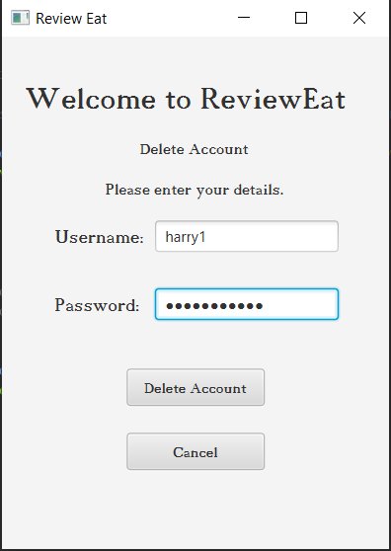You will be presented with a dialogue box informing that your account has been deleted. Click “OK”.

## Features of Review Eat (Tips and Tricks)

This section comprises some tips and tricks for the software.

### Search Box

When on Review Eat screen, if you want to find any particular restaurant, you can simply search for them. Simply, click on the search box and start typing, and the software will give back the results. The result is empty when the restaurant you searched for has not been added to the system yet.

If you want any restaurant to be added to the system that is not there, you can simply contact the developer(admin) who can add the restaurants.

### Filter restaurant based on cuisine

When on Review Eat screen, if you want to find a restaurant of a particular cuisine, you can filter the restaurant using the filter choice box. Simply click on “Filter By Cuisine” choice box, and you will be provided with a list of cuisines. When you click on any one of them, the list will be filtered to the restaurants of cuisine that you have selected.

### Sort the results

When on Review Eat screen, you can sort the restaurant by your preference. You can either sort them according to the name or based on the ratings. To do this, simply click on “Sort by” choice box which will provide you with options to choose between name and rating. Just click on the one that you prefer.

Note: The restaurants are sorted by name by default. When sorted by rating, the restaurant with the highest rating is displayed at the top while restaurants with a lower rating are displayed at the bottom. If no review has been added to that restaurant yet, you will see(NaN) besides its name.

### Want to go back to previous window?

If you want to go back to the previous window, all the screens have “Cancel” button. To go back, simply click on the “Cancel” or “Back” button.

### Logging out?

To log out of the system, simply click on “Log out” button on Review Eat window. The “Log out” button is on the right side of the search box.

## Trouble Shooting

When using the software, there can be several moments when you do not know that is going on. This section of the user guide is to help you during those situations.

### Logging In

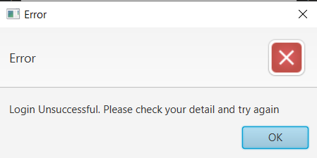When trying to log in to the system, you may encounter the following error:

This error is caused because of an invalid username or password.

To resolve this issue, you should make sure that you have entered the correct username and password. Register to the system if you have not done so yet.

### Registering to the system

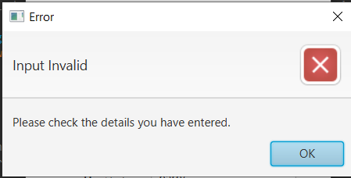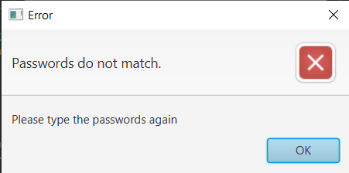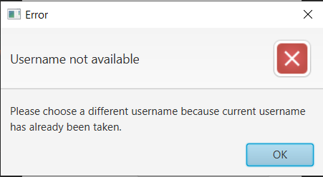When trying to register to the system, you may encounter the following errors:

1. Username Not Available

This error occurs when you try to choose a username that has already been taken by someone else.

To resolve this issue, you should choose a different username.

1. Passwords Do Not Match

During registration, the system wants you to enter the same password twice to confirm it. The error occurs when the passwords that you have entered are different from one another.

To resolve this issue, make sure that you have typed the same password on the “Password” text field and “Retype Password” text field.

1. Input Invalid

This error is caused due to input restrictions. Here is the list of restrictions that are implemented in the software:

* First Name and Second Name should have at least two characters and a maximum of 20 characters.
* Email must contain an “@” sign.
* Username must be 3 to 10 characters long, and it can only contain letters and numbers. No special characters are allowed.
* Password must be 6 to 20 characters long, and it can only contain letters and numbers. No special characters are allowed.

To resolve this issue, make sure that you have entered your details based on the above mention constrains.

### Updating the password

When trying to change your password, you may encounter the following errors:

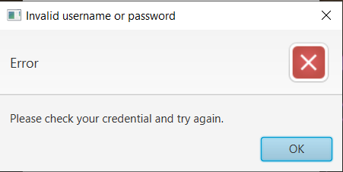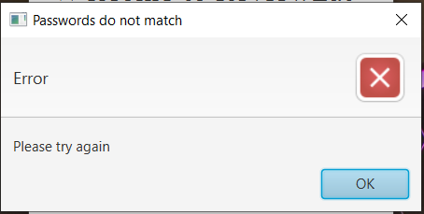

1. Invalid Username or Password

This error occurs when the username or password that you have entered cannot be validated.

To resolve this problem, make sure that you have entered your username and your password correctly.

1. Passwords do not match

As with the registration system, updating your password also requires your new password to be typed twice for confirmation. This error occurs when the new passwords that you have entered do not match with each other.

To resolve this issue, make sure you have entered the same password on both of the “New Password” text fields.

### Deleting an account

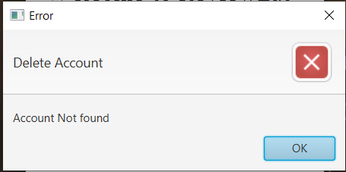When trying to delete your account, you may encounter the following error:

This error is caused because of an invalid username or password.

To resolve this issue, you should make sure that you have entered the correct username and password.

### Adding a review

You may encounter following errors when trying to add a review on a restaurant: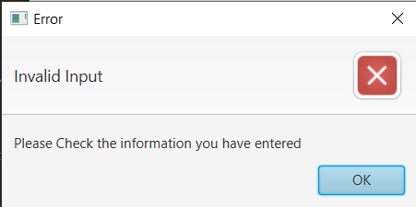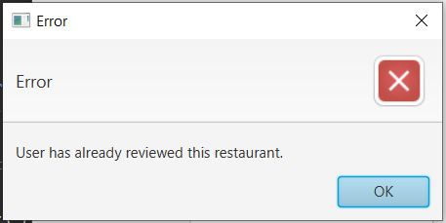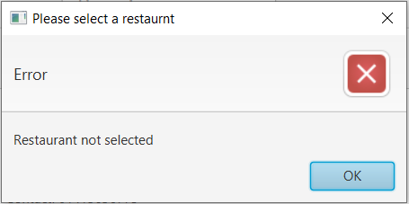

1. Restaurant not Selected

When on Review Eat screen, to be able to add a restaurant, you should click on (select) the restaurant before clicking on the “Add Review” button.

This error pops up when you try to click the “Add Review” button without selecting any restaurant.

To resolve this error, simply select a restaurant before clicking “Add Review” button.

1. User has already reviewed this restaurant

The system is designed such that a user cannot review a restaurant more than once.

The issue occurs when you try to add a review to a restaurant that you have previously reviewed. The system does not allow more than one review on the same restaurant.

1. Invalid Input

This error is caused due to input restrictions. The restriction is as follows:

* The rating must be an integer. (Since there is a choice box, this restriction does not affect your experience)
* The description must be 4 to 100 characters long.

To resolve the issue, make sure that you have entered the description based on the above mentioned constraints.

If there are any issues or errors that are not discussed above, please feel free to contact the developer on the contact details provided at the end of this document.

# Developers Contact Information

Yogesh Parajuli

Email: [yogeshparajuli56@gmail.com](mailto:yogeshparajuli56@gmail.com)

## Copyrights

The Review Eat Software is created and owned by YOGESH PARAJULI, 2020.